The course started with the agenda. And then a case was considered:

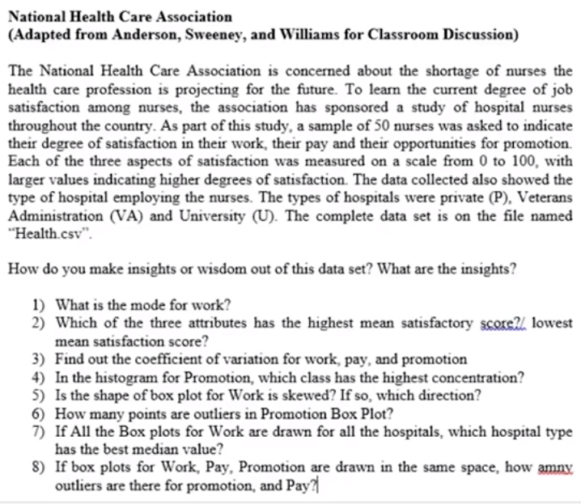The case with related questions:

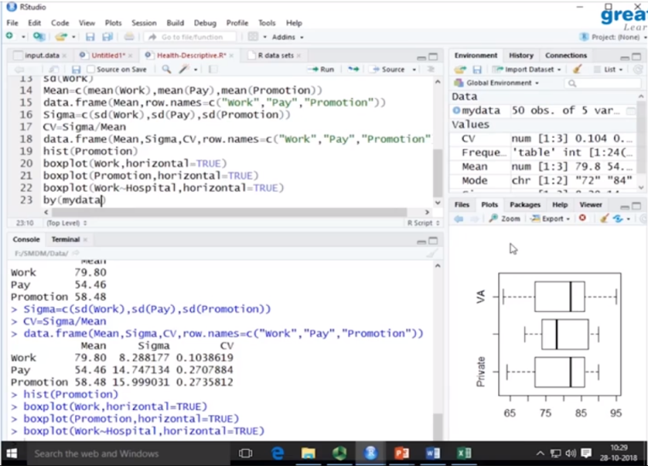The answer to the questions were answered by program coded on Rstudio.

Calculating median values, right skew and left skep, box plots for given case was done using Rstudio.

The importance of probability was highlighted with the fact that many cases come with uncertain or unclear outcomes but the near outcomes can be calculated and approximated.

The course later reverted back to the definition part of probability:

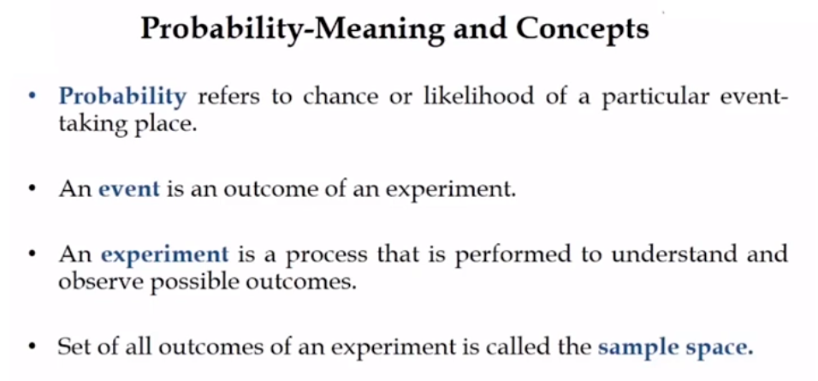

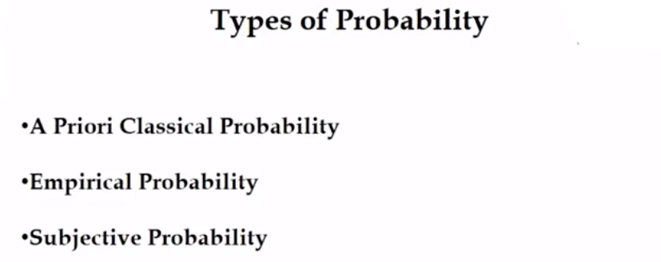

Empirical probability can also be called data driven probability.

Subjective probability is estimated probability. Subjective probability are usually improvised due time, it is revised as there will be minor mistakes about which we learn due course of time.

Uses of Venn diagrams was discussed.

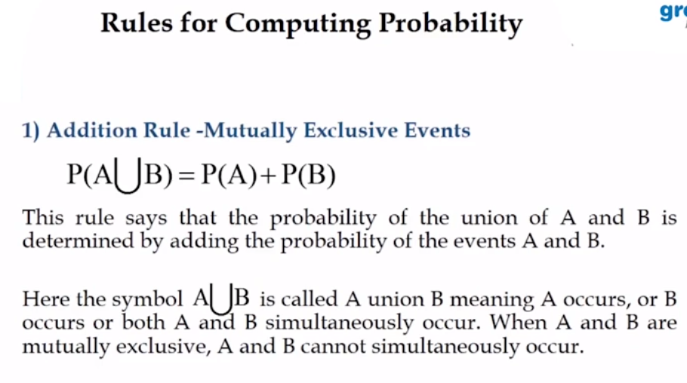

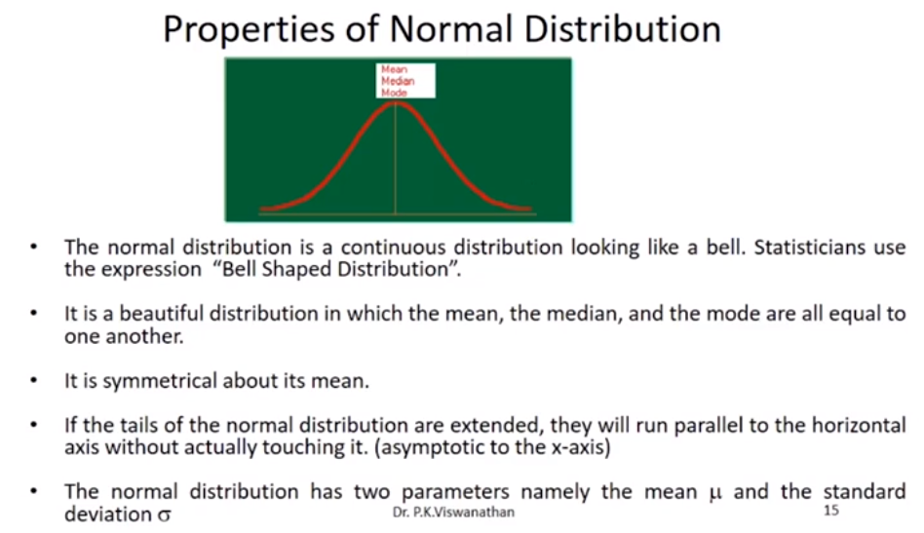

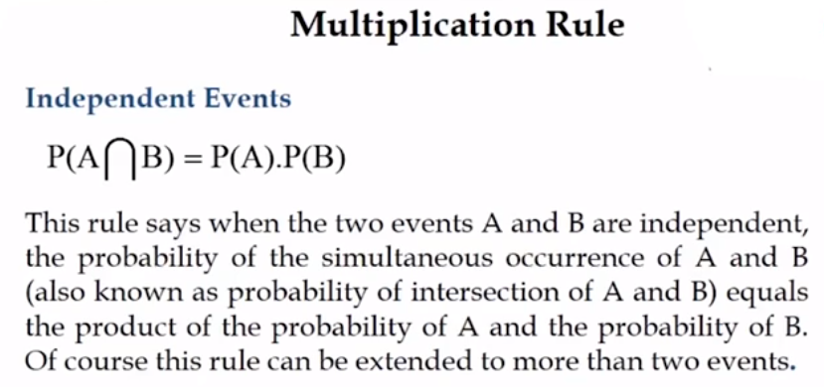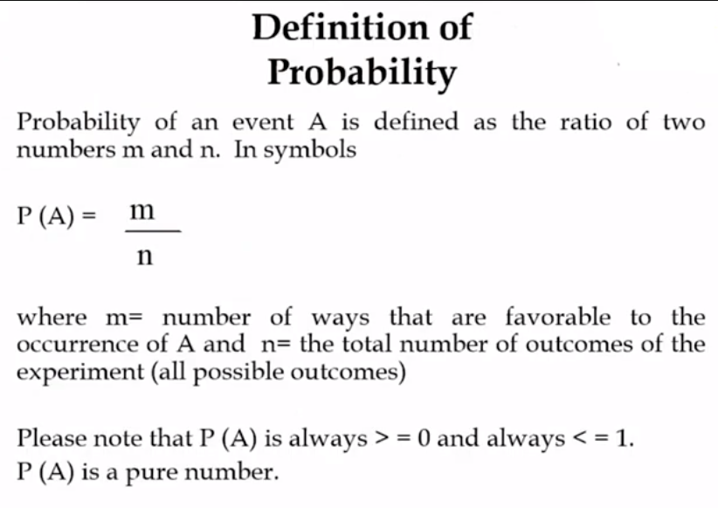And further Bayes’ theorem and normal distribution were discussed.